Step 1 — Paste Order Text
Paste the structured FedEx order text into the textarea. Supported format (tab or space separated):
SFC32026016
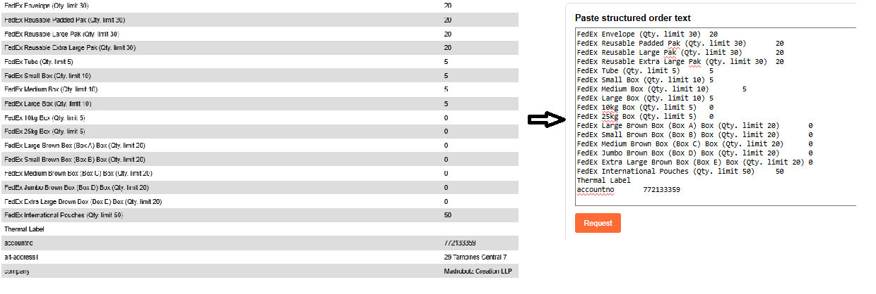
FedEx Envelope (Qty. limit 30) 20
FedEx Reusable Padded Pak (Qty. limit 30) 20
FedEx Reusable Large Pak (Qty. limit 30) 20
FedEx Reusable Extra Large Pak (Qty. limit 30) 20
FedEx Tube (Qty. limit 5) 5
FedEx Small Box (Qty. limit 10) 5
FedEx Medium Box (Qty. limit 10) 5
FedEx Large Box (Qty. limit 10) 5
The system auto-generates a random 12-digit account number as a demo. Replace it with the real account number before submitting.
(Note regarding customer privacy: There is no need to submit real customer contact information into this demonstration database. Data is automatically purged after 10 minutes.)

Step 2 — Request (Parse)
Click Request to parse the order text. The system will:
- Extract all item names, requested quantities, and per-item limits
- Extract customer fields: accountno, company, alt-address1, etc.
- Display a summary for review before submission

Step 3a — Submit Regular Order
Click Submit Regular Order to process with standard constraints:
- Allocation rules: Category limits applied proportionally. Item-specific limits applied. Quantities clamped to 0–limit range.
- Envelopes (max 10 total): FedEx Envelope
- Paks (max 30 total): FedEx Reusable Padded Pak, FedEx Reusable Large Pak, FedEx Reusable Extra Large Pak
- Boxes (max 10 total): FedEx Small / Medium / Large Box, FedEx 10kg / 25kg Box, FedEx Large / Small / Medium / Jumbo / Extra Large Brown Box
- Special Items (no category limit): FedEx International Pouches (item limit: 50), Thermal Label 154250 (limit: 2), Thermal Label 156148 (limit: 2)
*** Duplicate check (all 3 must match to block) ***
Same account number, Existing order status is pending, Identical items AND identical quantities.
>>> Upon submission of a Regular Order, the system employs an algorithm to proportionally allocate inventory based on individual customer demand
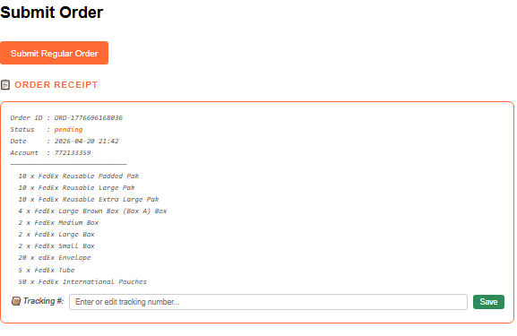

Step 3b — Modify Order (V3)
If we need to modify the quantity like partial quantity or alternative address:
Check 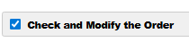
NOTE: Modified and VIP orders bypass duplicate check entirely (both require explicit approval / reason).
>>> Modifications to item quantities or Customer Alternative Addresses require a mandatory justification (e.g., 'Customer Request' or 'Approval') prior to submission
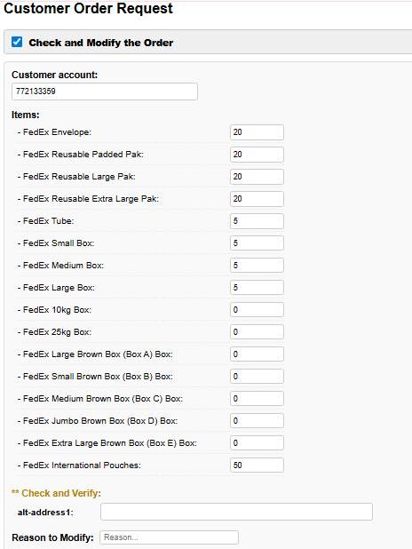

Step 3c — VIP Override (V2)
Use the VIP Submission panel to bypass all limits. Check Approved, enter a reason for the override, and click Submit VIP Order. 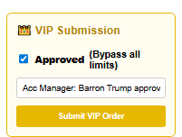
This VIP Order will accept whatever amount quantity, which address that Acc Manager approved.

Step 4 — Check Order Receipt (V4)
Every submission renders a styled receipt showing Order ID, Status, Date, Account details, and a Tracking # input field.
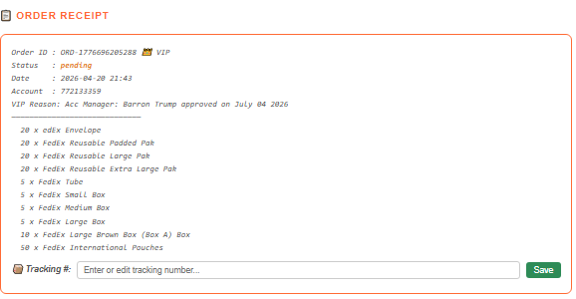

Step 5 — Tracking Numbers (V5)
Each receipt card has a 📦 Tracking # input field. Type or edit a tracking number and click Save.
>>> After saving the tracking number : Status pending >>> Shipped

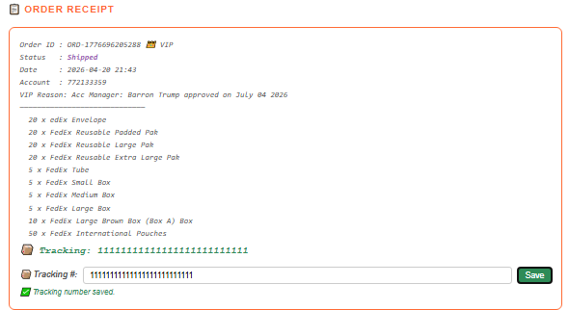

Step 6 — Order Lookup (V4)
Enter an Order ID in the Order Lookup panel to fetch a single receipt.
For example: use the VIP order above “ORD – 1776696205288” to get the receipt of that VIP Order
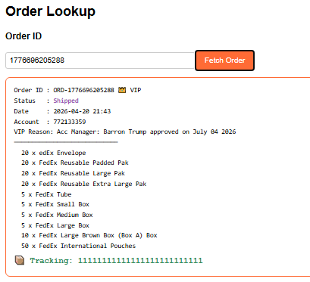

Step 7 — Email Order Receipt (V6)
Now we want to send that VIP “ORD – 1776696205288” receipt to the Customer
Check "📧 Email order Receipt" to reveal the email composer. It automatically populates the fetched order receipt into the Message body.
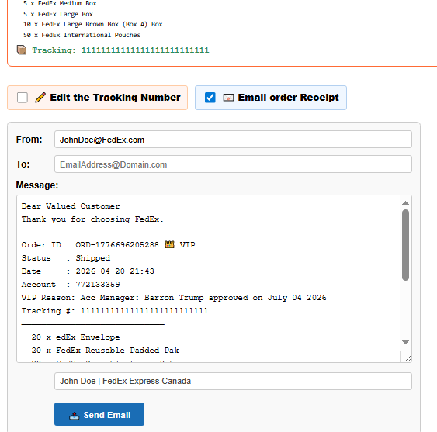

Step 8 — Account History (V5)
Enter an account number in Order History and click Fetch History to display full receipt cards for every order under that account.
For example, use the account above
Date : 2026-04-20 21:25
Account : 772133359

The 1st order is the VIP Order 1776695883557 that already got the Tracking number Shipped
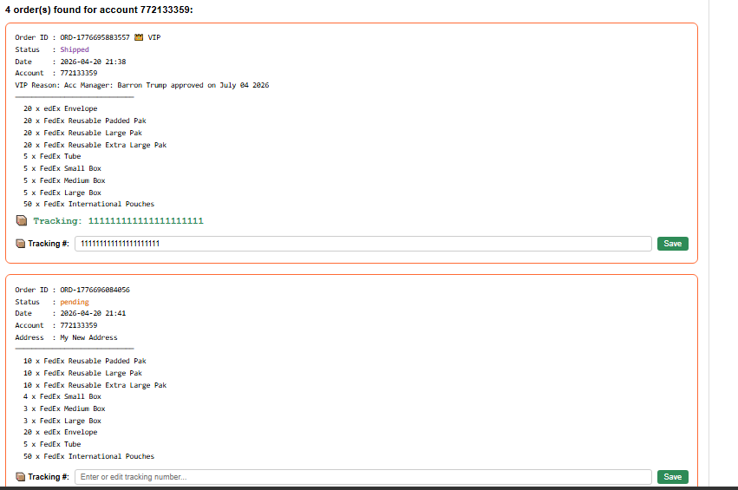
The 2nd order is the new Modified Address Order 1776696084056 which is still pending.

Step 9 — Return, Reroute, & Modified Tracking (V7)
Update the existing tracking number in Order Lookup or Account History and click Save to instantly store the new routing information.
For Example: if we want to change the tracking of the VIP Order 1776695883557 (due to wrong address, lost ect) > We look for that order in the Order Lookup and click the checkbox Edit the Tracking Number > and then enter the new Tracking number
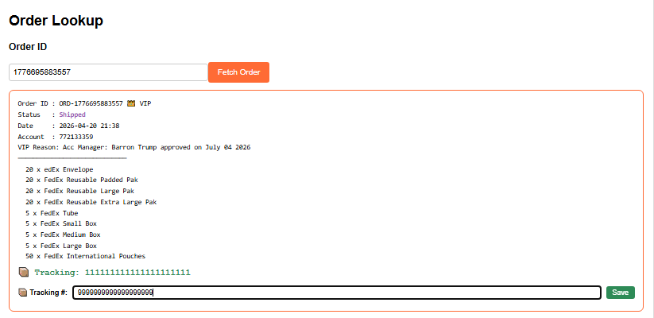

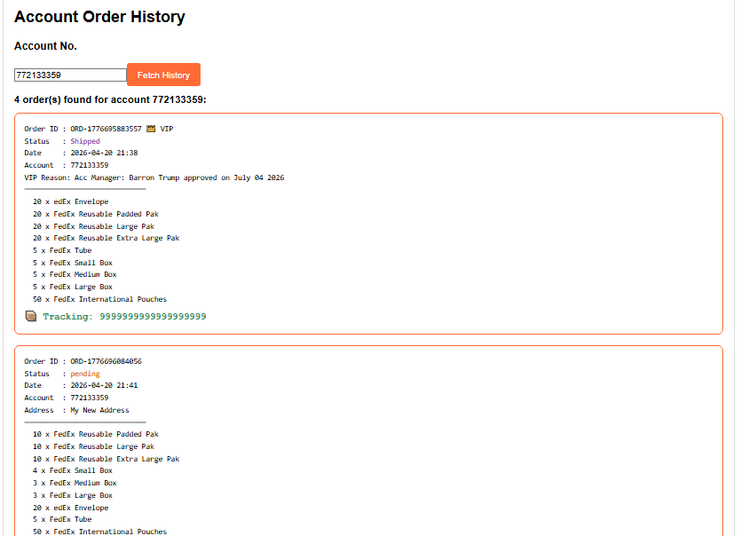

🔒 Validation Rules
- accountno is required for all submissions
- Reason to Modify is required for modified orders
- VIP requires Approved checkbox + reason
- Duplicate: blocked only when account + pending + same items + same qty

Email: BenTran.Phoenix@gmail.com
Source code available on GitHub: github.com/PhoenixWeaver

